# Selection-dependent inputs and client field rules

Selection-dependent inputs require users to enter additional information related to an initial selection before they can complete a form. In almost all cases, it allows making web forms simpler and more responsive to user actions and personalizing forms depending on visitors’ features.

Selection-dependent inputs require forms to be dynamic in client side. By default, the [Web Forms for Marketers](http://sdn.sitecore.net/Products/Web%20Forms%20for%20Marketers/Web%20Forms%20for%20Marketers%202,-d-,3.aspx) module does not provide this behavior but it provides the field rules engine ([5.2 Configuring Web Form Fields](http://sdn.sitecore.net/upload/sdn5/products/web_forms2/web%20forms%20for%20marketers%20v2_3%20user%20guide-usletter.pdf)) allowing adding new and extending existing fields behavior.

# Client Side Field Actions

Selection-dependent inputs are implemented as a set of Web Forms for Marketers field actions.

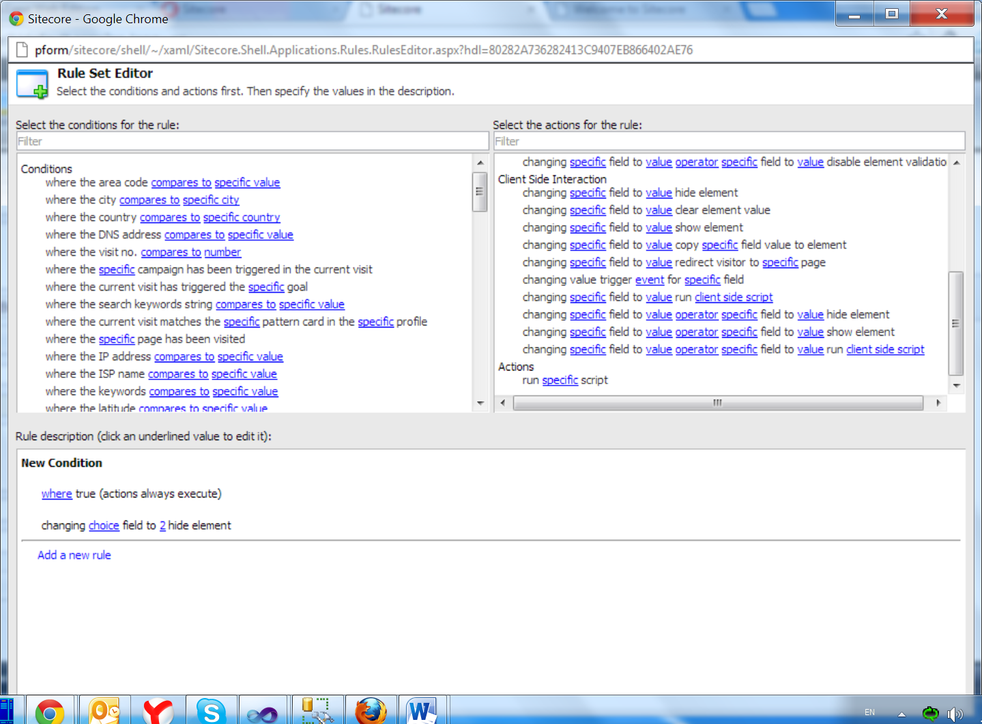

* Changing specific field to value hide element

The selected element is hidden when the specified field matches to the specified value.

* changing specific field to value show element

The selected element is shown when the specified field matches to the specified value.

* changing specific field to value clear field value

The selected element value is cleared when the specified field matches to the specified value.

* changing specific field to value copy specific field value

The selected element value is taken from another field when the specified field matches to the specified value.

* changing specific field to value redirect visitor to specific page

The visitor is redirected to the specified page when the specified field matches to the specified value.

* changing value trigger event for specific field

Triggers the specified event for the specified field when value of the selected field is changed

Note: possible event values – [HTML DOM events](http://www.w3schools.com/jsref/dom_obj_event.asp)

* [changing specific field to value run client side script](http://s651/sitecore/shell/~/xaml/Sitecore.Shell.Applications.Rules.RulesEditor.aspx?hdl=A47F1A78367D4EC998F148AFA6C11EE8)

Runs client side script when the specified field matches to the specified value.

* [changing specific field to value operator specific field to value hide element](http://s651/sitecore/shell/~/xaml/Sitecore.Shell.Applications.Rules.RulesEditor.aspx?hdl=A47F1A78367D4EC998F148AFA6C11EE8)

The selected element is hidden when the specified fields matches to the specified values.

**Note**: possible operator values: and / or

* [changing specific field to value operator specific field to value show element](http://s651/sitecore/shell/~/xaml/Sitecore.Shell.Applications.Rules.RulesEditor.aspx?hdl=A47F1A78367D4EC998F148AFA6C11EE8)

The selected element is shown when the specified fields matches to the specified values.

**Note**: possible operator values: and / or

* [changing specific field to value operator specific field to value run client side script](http://s651/sitecore/shell/~/xaml/Sitecore.Shell.Applications.Rules.RulesEditor.aspx?hdl=A47F1A78367D4EC998F148AFA6C11EE8)

Runs client side script when the specified fields matches to the specified values.

**Note**: possible operator values: and / or

**Note**: prefer to use condition “where true (action always execute)” for all client side actions.

## Example: Changing value automatically hide/show a field

In the following example, visitors are registering to a training event. The visitors have a choice how to get a course invoice. On the one hand a part of visitors wants to receive invoice by email and in this case the form should not require any additional user information.



On the other hand the rest of visitors prefer to receive invoice by mail. This choice requires visitors to enter an address, e.g. street, city, country.

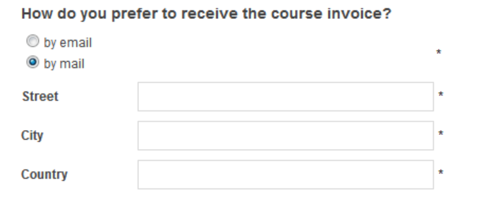

Street, City, Country is to be shown only when “How do you prefer to receive the course invoice?” equals to “by mail”. In all other cases address fields is to be hidden.

To ensure that Street, City Country works as described, you must configure a rule for Street, City Country fields.

To configure a rule for the Street field:

1. In the Form Designer, select the Street field and click Edit in the Rules section.

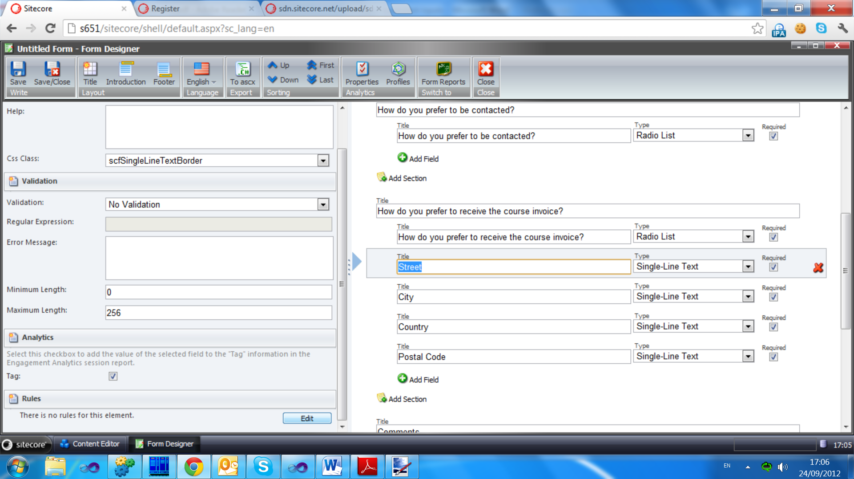

1. In the Rule Set Editor, in the Select the condition for the rule field, in the Filter field, enter “always” and only the conditions that contain the word “always” are displayed.

**Note**: prefer to use condition “where true (action always execute)” for all client side actions.

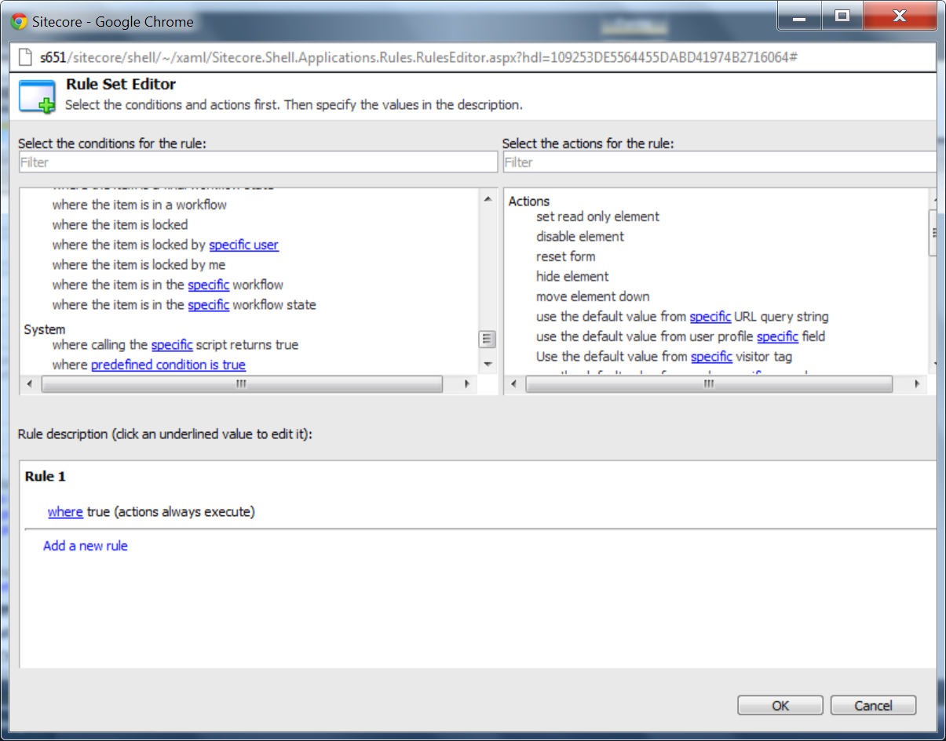

1. In the Select the action for the rule field, select the changing specific field to value show element action. This rule appears in the Rule Description section.

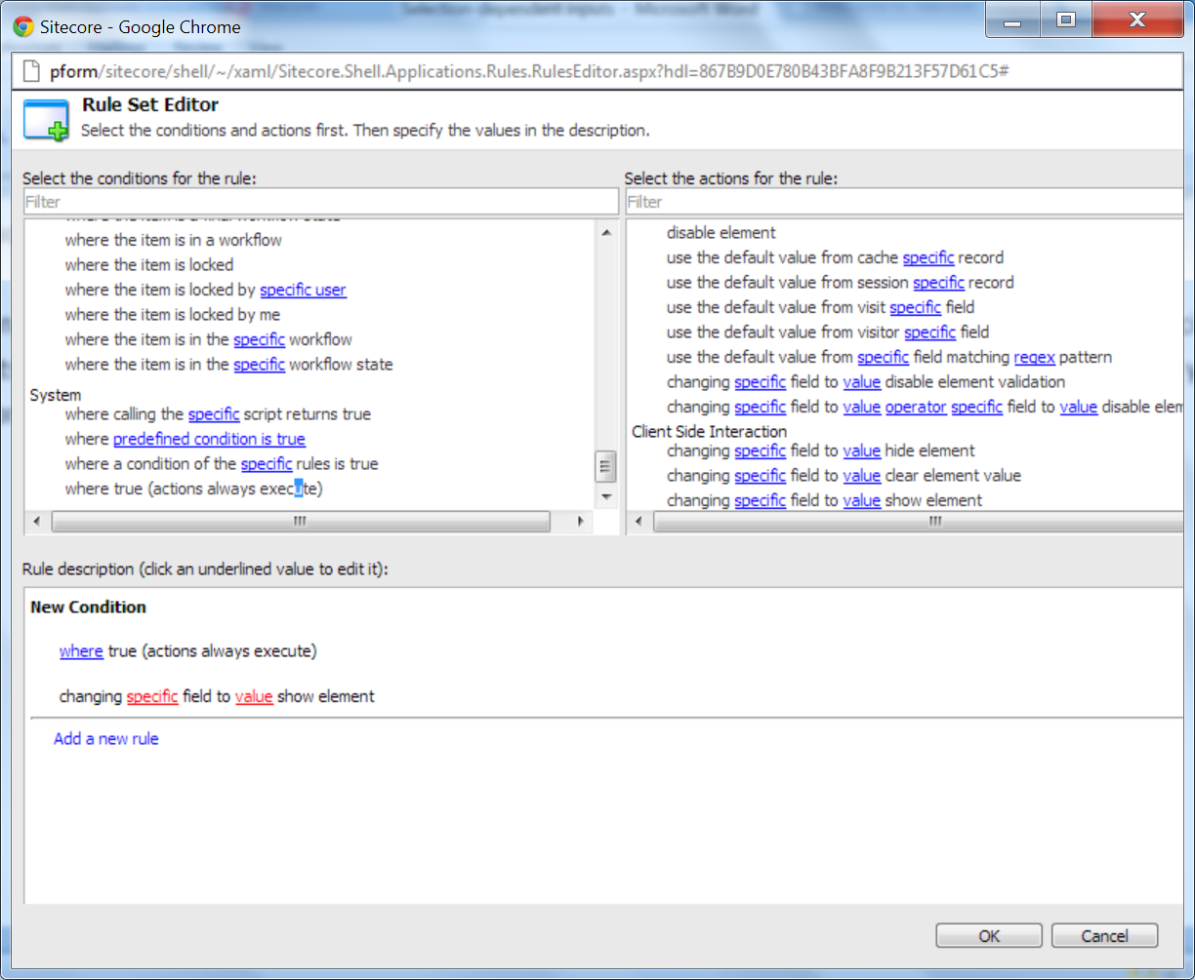

1. In the Rule Description section, the underlined key words in red indicate that you must specify its values. In the changing field to value show element string, click field and select “How do you prefer to receive the course invoice?”

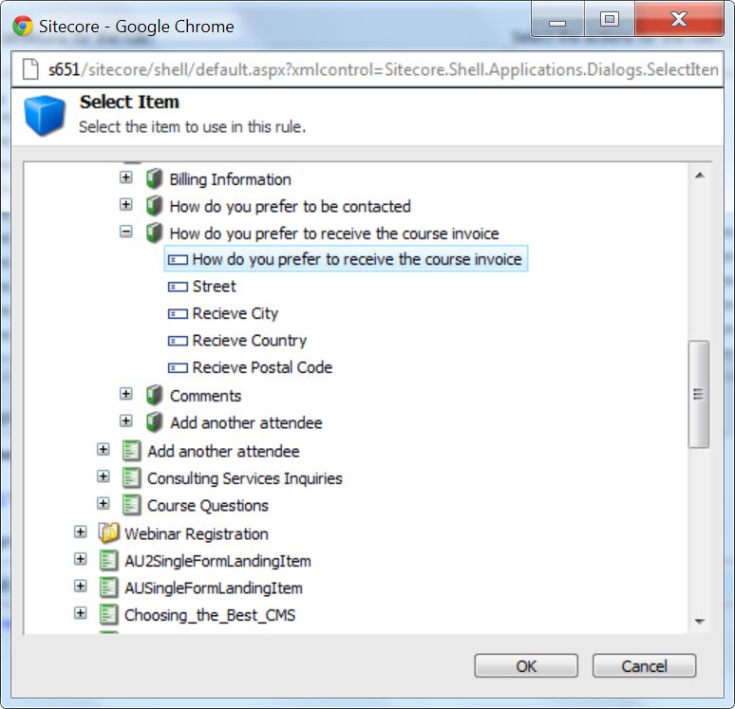

1. In the changing field to value show element string, click value and enter “by mail”

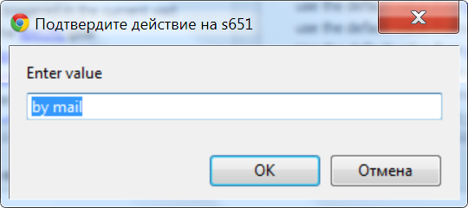

**Note**: The value can be any regex expression.

1. In the New condition string, click Edit and enter the new name. For example, Show when by mail selected.

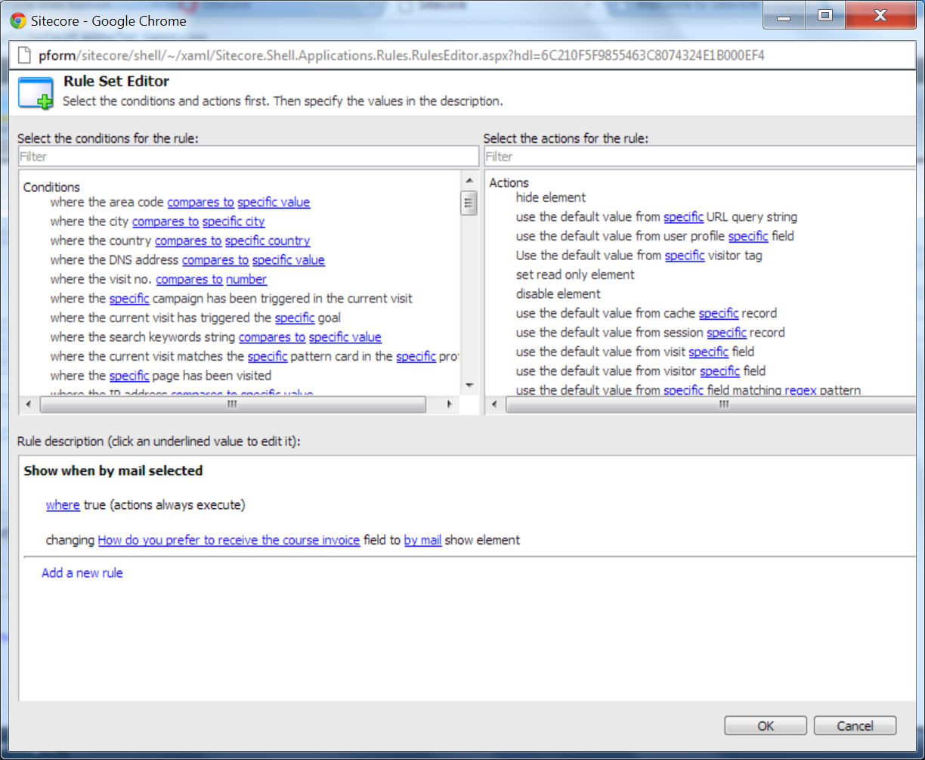

1. In the Select the action for the rule field, select the changing field to value hide element action. This rule appears in the Rule Description section.

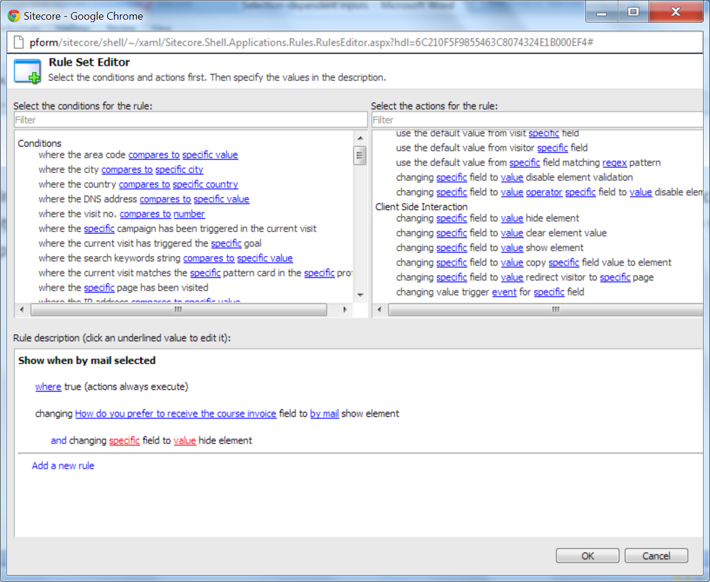

1. In the Rule Description section, the underlined key words in red indicate that you must specify its values. In the changing field to value show element string, click field and select “How do you prefer to receive the course invoice?”



1. In the changing field to value show element string, click value and enter “^((?!by mail).)*$” (this regex means - any value except for ‘by mail’)

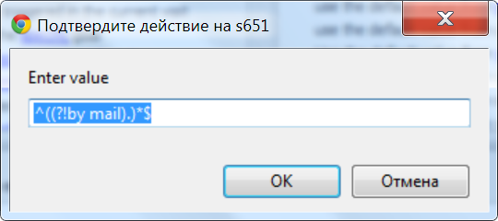

1. Save the changes.

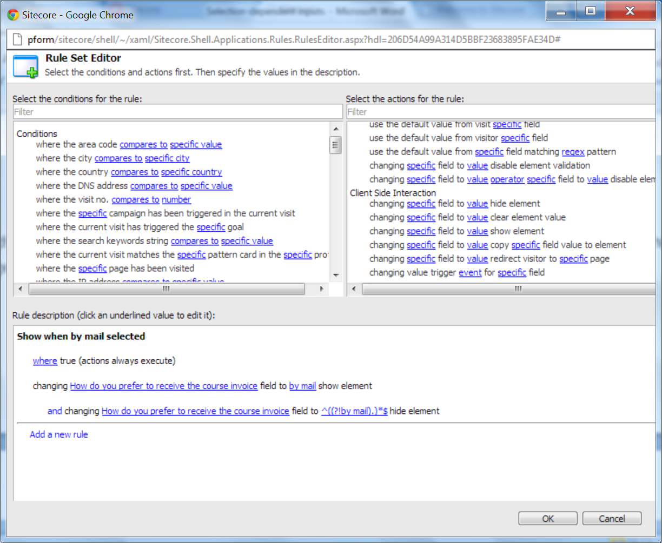

Repeat described above steps to configure the rule for the City and Country fields.